**OOP LAB 8 TASKS**

20K-1052(S.M.HASSAN ALI)

**Q1.**

#include<iostream>

using namespace std;

class Animal{

public:

animalSound(){

cout<<"The animal makes a sound"<<endl;

}

};

class Cat: public Animal{

public:

animalSound(){

cout<<"The cat says meow"<<endl;

}

};

class Dog: public Animal{

public:

animalSound(){

cout<<"The cat says bow wow"<<endl;

}

};

class Duck: public Animal{

public:

animalSound(){

cout<<"The duck says quack quack"<<endl;

}

};

int main(){

Animal a1;

a1.animalSound();

Cat c1;

c1.animalSound();

Dog d1;

d1.animalSound();

Duck d2;

d2.animalSound();

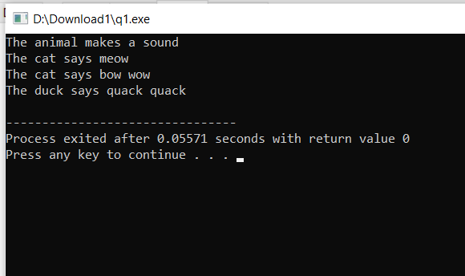}

**Q2.**

#include<iostream>

using namespace std;

class Calc{

public:

float h1;

func(float r){

h1=r*r*r;

cout<<"The Volume of Cylinder is: "<<h1<<endl;

}

func(float r,float h){

h1=3.142*r*r*h;

cout<<"The Volume of Cylinder is: "<<h1<<endl;

}

func(float l,float b,float h){

h1=3.142*l*l*h;

cout<<"The Volume of Rectangular Box is: "<<h1<<endl;

}

};

int main(){

Calc a;

a.func(5.5);

a.func(3.2,8,9);

a.func(4,6.7,4.3);

}

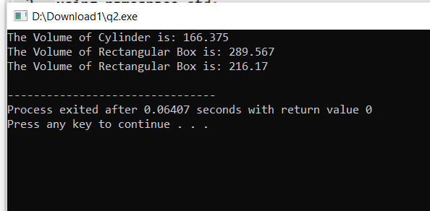

**Q3.**

#include<iostream>

using namespace std;

class Person{

public:

int employeeid;

getData(){

}

displayData(){

}

};

class Admin:public Person{

public:

string noe;

float min;

getData(){

cout<<"Enter the employee id of admin: ";

cin>>employeeid;

cout<<"Enter the admin name: ";

cin>>noe;

cout<<"Enter the montholy income: ";

cin>>min;

}

displayData(){

cout<<"The admin name: "<<noe<<endl;

cout<<"The employee id is: "<<employeeid<<endl;

cout<<"The montholy income is: "<<min<<endl;

}

bonus(){

float bb;

bb=(min*12) +((min*12)*5/100);

cout<<"The anual salary after 5% bonus is: "<<bb<<endl;

}

};

class Accounts:public Person{

public:

string noe;

float min;

getData(){

cout<<"Enter the employee id of accounts: ";

cin>>employeeid;

cout<<"Enter the accounts name: ";

cin>>noe;

cout<<"Enter the montholy income: ";

cin>>min;

}

displayData(){

cout<<"The admin name: "<<noe<<endl;

cout<<"The employee id is: "<<employeeid<<endl;

cout<<"The montholy income is: "<<min<<endl;

}

bonus(){

float bb;

bb=(min*12) +((min*12)*5/100);

cout<<"The anual salary after 5% bonus is: "<<bb<<endl;

}

};

int main(){

Admin a1;

a1.getData();

cout<<endl;

Accounts a2;

a2.getData();

cout<<endl;

a1.displayData();

cout<<endl;

a1.bonus();

cout<<endl;

a2.displayData();

cout<<endl;

a2.bonus();

cout<<endl;

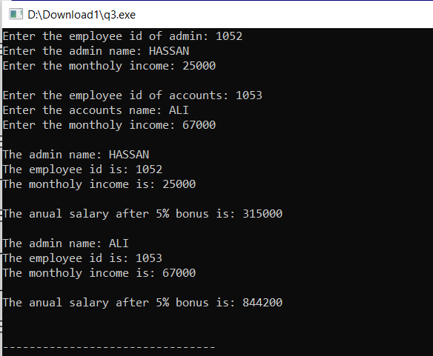}

**Q4.**

#include <iostream>

using namespace std;

class Product {

public:

calc(int i,int j) {

cout << "\nThe product of two integers is: " << i*j;

}

calc(int i,int j, int k) {

cout << "\nThe product of three integers is: " << i*j*k;

}

calc(double i, double j) {

cout << "\nThe product of two decimal digits is: " << i*j;

}

calc(double i, double j, double k) {

cout << "\nThe product of three decimal digits is: " << i*j*k;

}

};

main() {

Product p;

p.calc(3,5);

p.calc(4,8,6);

p.calc(3.3,5.5);

p.calc(2.8,6.4,9.7);

}

